**JotunheimenPlaces**

**1- React Native App**

**2- Firebase Admin Website**

1. React Native app

* Config setting

Configuration information is in **./config.js**

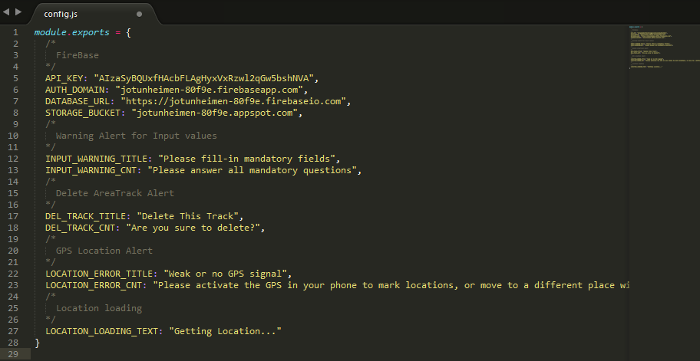

We can modify config information in this file for this RN app.

* + Firebase config

1. Login with your gmail.
2. Please go to this url. [**https://console.firebase.google.com/**](https://console.firebase.google.com/)**,** then click our Jotunheimen app.

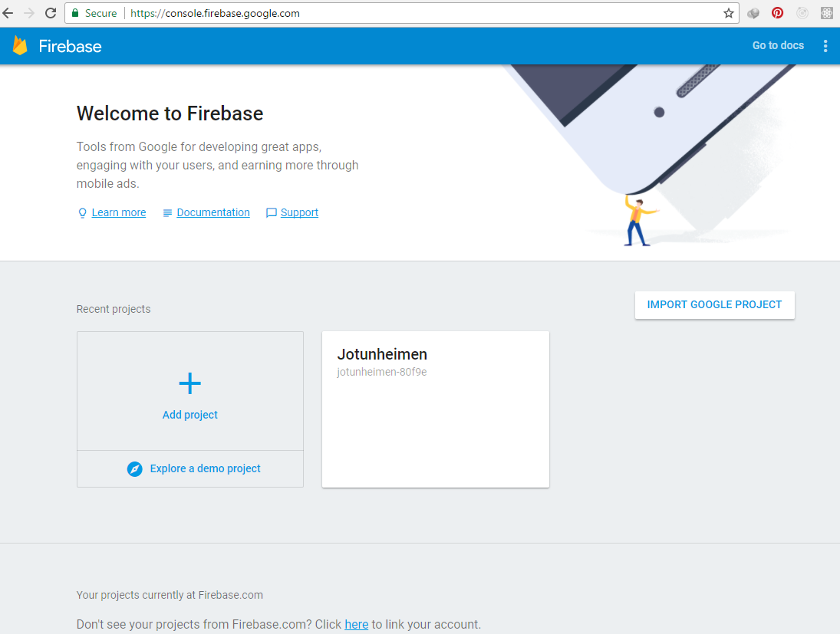

1. Click **Add Firebase to your web app**

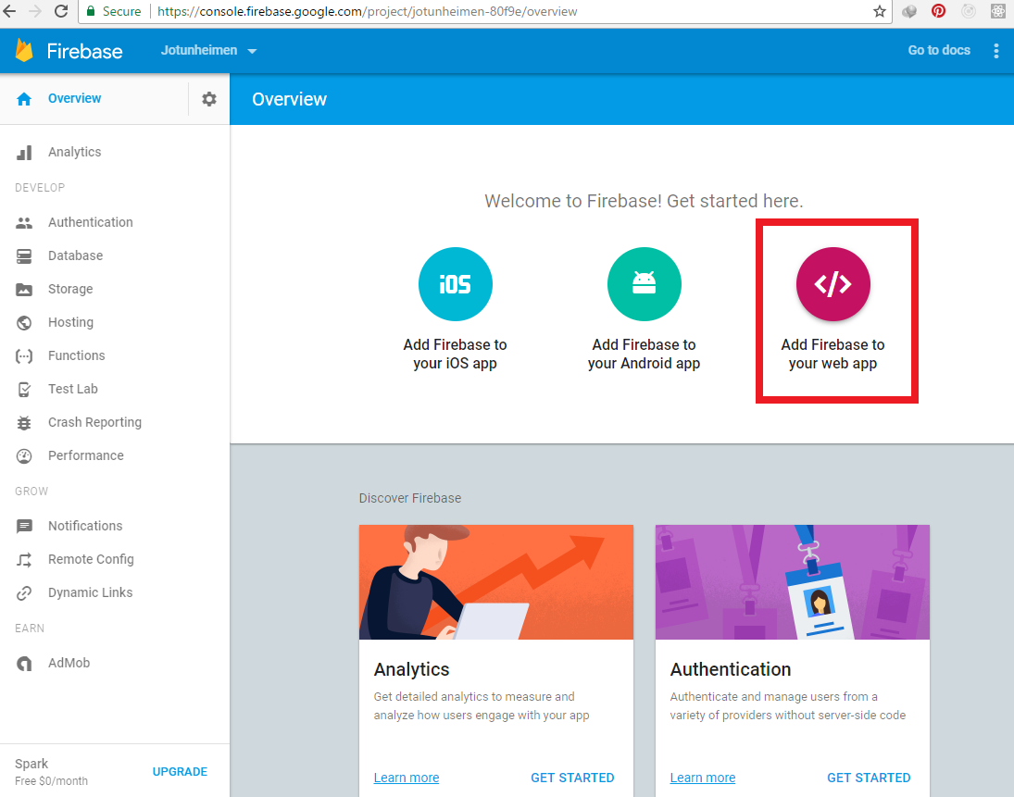

1. You can see config information for our RN app.

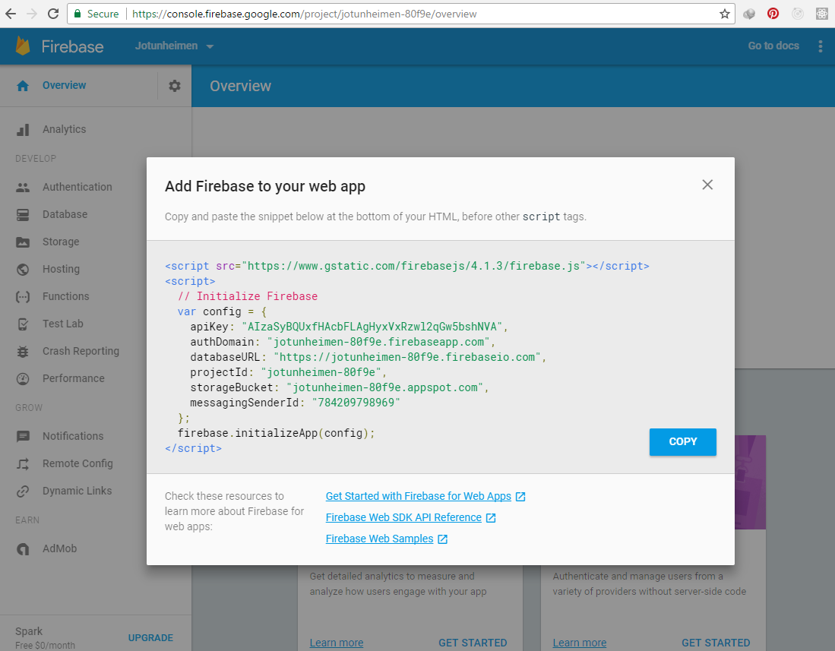

* IOS
  + Open your terminal and go to RN app directory, execute this command.

**react-native run-ios**

* + Or, Go to RN app directory, open **JotunheimenPlaces.xcodeproj** in **./ios** directory

Run “Build and the run the current.scheme”

* Android
  + Open your terminal and go to RN app directory, execute this command.

**react-native run-android**

* + Get signed APK

Open your terminal and go to RN app directory

**cd android**

**gradlew assembleRelease**

Then you can find **app-release.apk** in **./android/app/build/outputs/apk.**

If this fails, try **gradlew clean** and **gradlew assembleRelease.**

* Notice

We use **react-native-gps** npm for getting location in Android.

I modified and added some code into **./node_modules/react-native-gps** npm for Android.

So, we have to keep our **node_modules**

1. Firebase Admin website

* Config setting

Firebase config information of Admin site is in **./config.php**

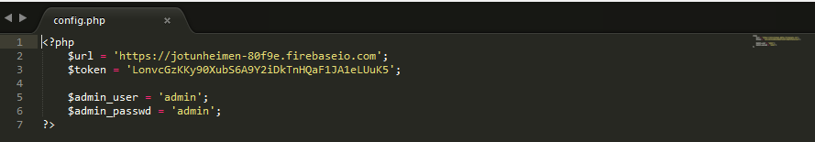

Well, Where does the token value come from? Let’s see.

1. Click **Settings->Project settings** at top-left in Firebase app page.

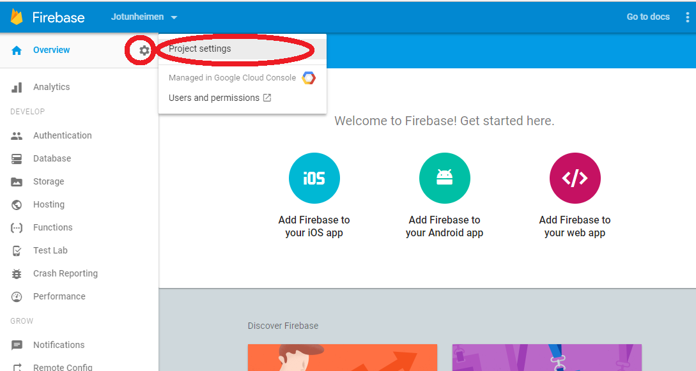

1. Open **SERVICE ACCOUNTS** tab, Click **Database Secrets** sub tab and **Show** button.

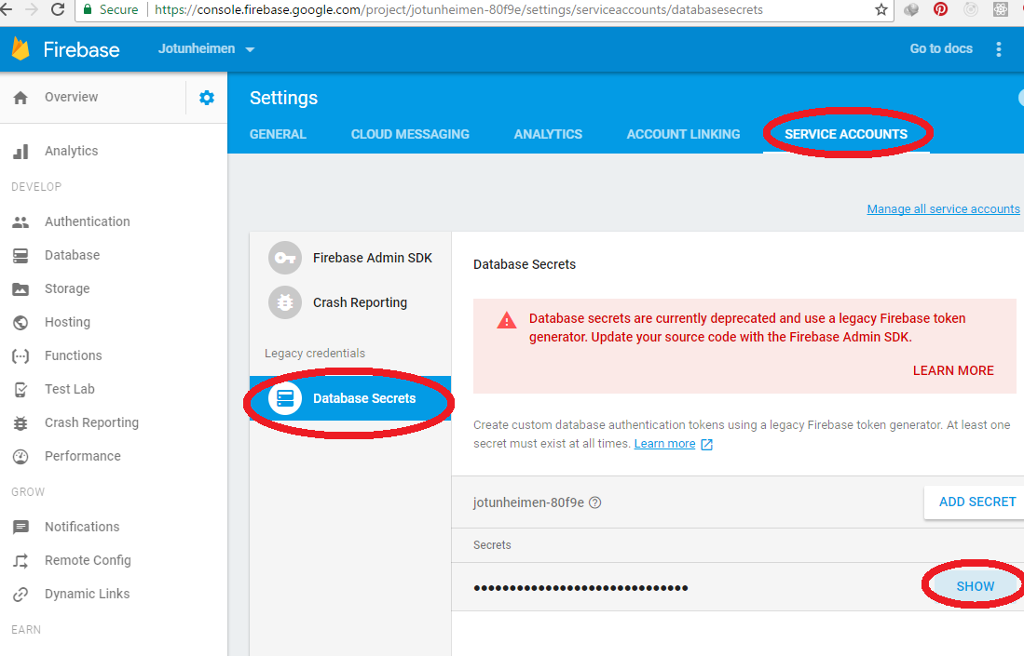

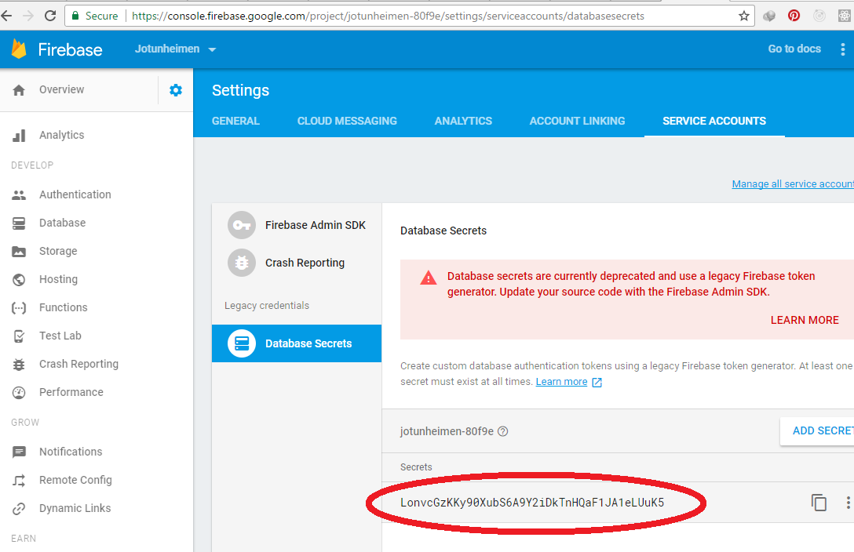

* Deploy admin website to Heorku

App: jotunheimen-places

